PT8612 modification to improve jitter on Rev. 1.3 PCB
1007-03-27 Thomas Holm Hansen

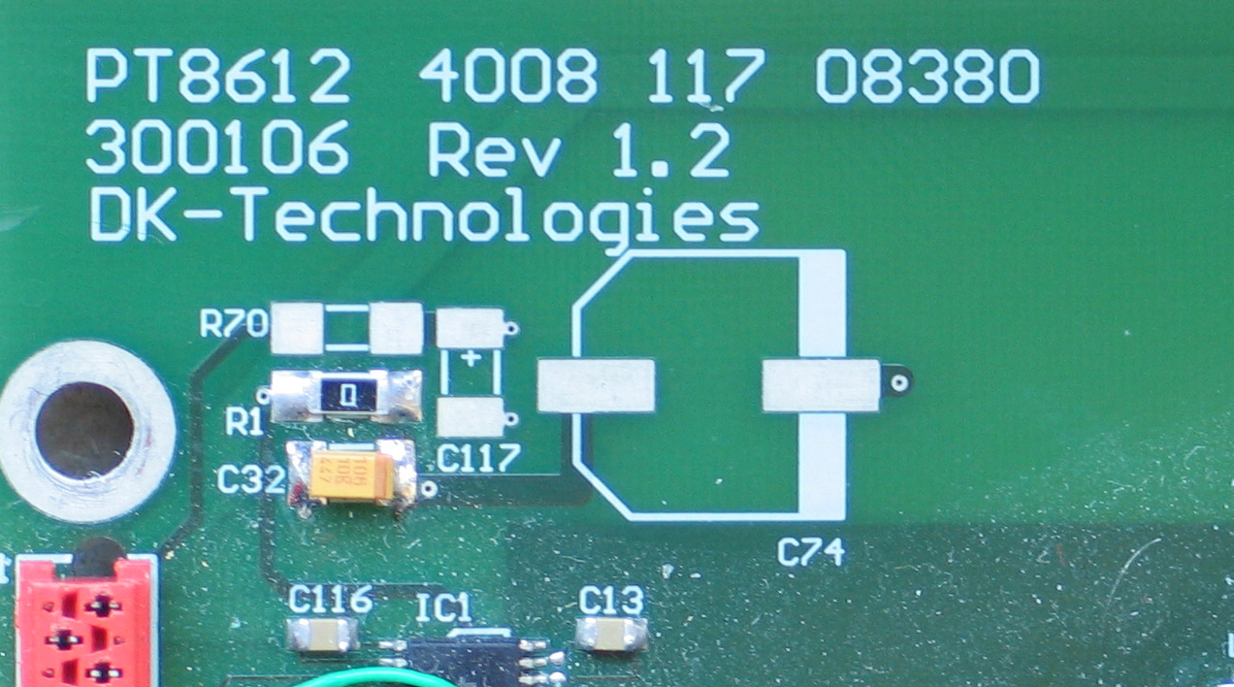
The purpose of this modification is to bypass the ICS clock IC's (IC9, 10, 11, 12) and use VCXO's instead. This is done by making the following modification.

- Remove resistors R10, R33, R34 and R35.

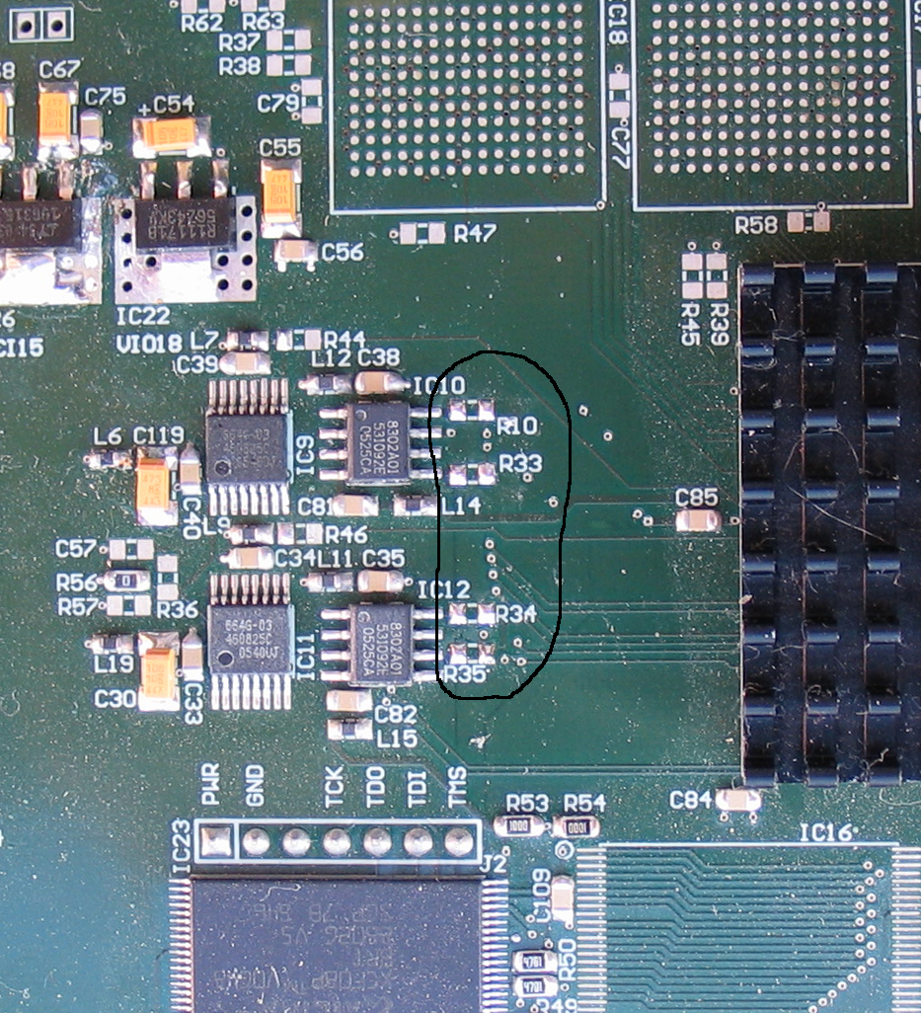

- Using thin wire, make 4 connections as shown in red lines (PCB down side under the big FPGA).
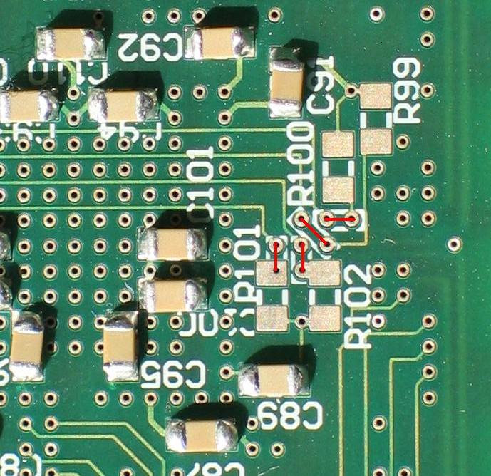

- Mount following components:

IC29 | VCXO SILabs 550 148M352
IC27 | VCXO SILabs 550 148M500
R80, R85 | 3k9 R
C73, C111 | 680 nF
L38, L39 | BLM18AG102SN10
R81, R82, R83, R84 | 0 R
C88, C90 | 100nF

- Load firmware that supports external VCXO's.

